Bunscoil na Toirbhirte
Mitchelstown, Co. Cork.


Religion Policy

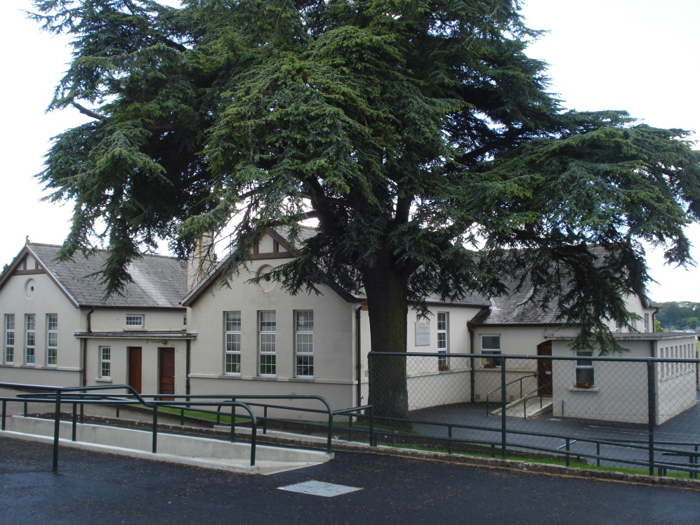

TABLE OF CONTENT
Schedule for a Catholic School
Venerable Nano: Vision Statement for Catholic schools
Scope of the policy for Religious Education
Mission Statement
Nature of Religious Education
Aims of Religious Education
Rationale
Curriculum
Facilities and Resources
Withdrawal from religious education
Staffing
Sacred Space
Religious Imagery
Outreach programmes
Chaplaincy services
Retreats
Parent involvement
Diocesan support
Monitoring, review, timeframe of Policy
Signature page

Schedule of a Catholic School
Bunscoil na Toirbhirte, a Roman Catholic school (which is established in connection with the Minister) aims at promoting the full and harmonious development of all aspects of the person of the pupil: intellectual, physical, cultural, moral and spiritual, including a living relationship with God and with other people.
The school models and promotes a philosophy of life inspired by belief in God and in the life, death and resurrection of Jesus Christ.
The Catholic school provides religious education for the pupils in accordance with the doctrines, practices and tradition of the Roman Catholic Church and promotes the formation of the pupils in the Catholic Faith.

Bunscoil na Toirbhirte is a Presentation Primary School.
Vision Statement for our Catholic Schools
We, the Presentation Sisters, believe that there is no such thing as a value neutral education. All schools of necessity and implicitly espouse a vision of the human person and give expression to a particular ethos of their choices, actions and priorities.

The Education Act 1998 recognises the value of the “founding intention” of the school and the importance of maintaining its “characteristic spirit”. The challenge is to ensure that both the founding intention of the Foundress, Nano Nagle, and characteristic spirit of our Presentation schools are retained in the ever changing web of social, economic and educational contexts.

The Catholic school is a place of hospitality, where everyone feels cherished and cared for. It is called to give real witness to Gospel values and the narrative that we belong to. What makes it distinctive is its attempt to generate a community that is permeated by the Gospel spirit of freedom and love. As such it encompasses collective attitudes, beliefs, values, traditions, aspirations and goals. It is a community where faith inspires the culture and where dialogue between faith and life and between faith and culture is fostered.

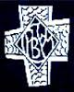

As a Catholic school this Religious Education Policy will impact on the whole school community. Support for the implementation of the policy will come from a number of groups.

Board of Management:
To approve the policy, ensure its implementation and monitor its review.

Principal and Deputy Principal:
To support the procedures of the policy and ensure its effective implementation.

School Staff:
As a Catholic school, the hope is that the whole staff embraces and safeguards the Ethos of the school and supports the cross culture of Religious Education.

Classroom Teachers:
To implement and review the policy. To ensure a high standard and effective delivery of Religious Education.

Sacramental Chaplain:
To assist with the implementation and review of the policy and to support the staff.

Pastoral Care Personnel:
Support staff monitor the effects of the policy and provide support and guidance to the children.

Parent(s)/Guardian(s):
To support the Ethos of the school and the Religious Education programme and facilitate the faith formation of their children.

Children:
To participate in the Religious Education programme and related activities and to cultivate an openness to other religious traditions.

Bunscoil na Toirbhirte, Mitchelstown, Co. Cork.

Religious Education Policy

Bunscoil na Toirbhirte is a Catholic school. Our school’s philosophy of education is inspired by the Gospel of Jesus Christ. This philosophy of education aspires to create an open, happy caring Christian community which recognises and fosters the unique dignity and value of each person. It aims at providing students with an education for life. Every student is encouraged to achieve academic excellence to grow spiritually, emotionally, socially, creatively, physically and to develop an awareness and concern for the poor and under privileged.

NATURE OF RELIGIOUS EDUCATION
As a Catholic school Religious Education is a core subject on the school curriculum and an integral part of the ethos of the school. Religious Education is provided for pupils in accordance with the doctrines, practices and traditions of the Catholic Church that derives its trust and ultimate foundation from the person of Christ. Religious Education has nothing in common with indoctrination that amounts to teaching a student a religious way of behaving and believing. This type of teaching deliberately harms students by undermining their natural ability to reason. In contrast, as a school we are committed to the deepest respect for both faith and reason as they contribute significantly to the formation of rational and mature citizens of democratic society. Three types of learning in Religious Education are evident in our school.

- ‘Learning into religion’
Children are provided with religious instruction and experience, such as prayer and sacramental participation that will help them to grow into their faith and in their understanding of the Catholic tradition.
- ‘Learning about religion’
While particular focus is given to Christianity, children are exposed to a broad range of religious traditions and to the non-religious interpretation of life. Such a broad exposure seeks to develop in children, powers of tolerance and mutual understanding and the skills needed to engage in meaningful dialogue with those of other, or of no religious traditions.
- ‘Learning from religion’
Children evaluate both what has been learned and how it has impacted on their daily lives. Children are invited to learn from what they are discovering.
Religious Education that the school provides is open to, and inclusive of, all children, regardless of their faith background

AIMS OF RELIGIOUS EDUCATION
In Bunscoil na Toirbhirte Religious Education endeavours to:
- Develop in children a knowledge and understanding of their own religious tradition and beliefs, with respect for religious traditions and beliefs of others.
- Help children grow in their identity as persons created in the image and likeness of God.
- Help children respond to God’s love through love: by showing love for themselves, for each other, for God and all of Creation.
- Deepen in children an understanding of what it means to be a disciple of Jesus and how to participate in the mission of the Church
- Foster awareness in children of shared values such as justice, peace, the dignity of the human person.
- Heighten children awareness, empathy and compassion for local needs/issues and global problems.
- Prepare children for the sacraments of First Penance, First Communion and Confirmation.
- Give children accurate, clear, age and ability appropriate information.
- Prepare children for living in community with people of their own and other faith traditions and none.

RATIONALE
The Religious Education Policy allows us to reflect on what it means to be a Catholic School and to articulate our commitment to it.

CURRICULUM
The Catholic characteristic ethos underpinning our school permeates the whole school day. Thirty minutes in each school day is devoted to Religious Education as well as time for prayer, morning and night prayers, Grace before and after meals and other related activities.

RELIGIOUS EDUCATION PROGRAMME FOR JUNIOR AND SENIOR INFANTS
‘Grow in Love’
The aim of the ‘Grow in Love’ programme is: to help children mature in relation to their spiritual, moral and religious lives, through their encounter with, exploration and celebration of the Catholic faith.

Content of the GROW IN LOVE programme:
My family.
The Holy Family.
Our world.
Advent and Christmas.
Stories about Jesus.
Holy Week and Easter.
The Church.
Water/ Food.
Baptism.
We Give Thanks - The Mass.
Text Book: ‘Grow in Love’ Teacher’s Manual. Children’s Book.

RELGIOUS EDUCATION PROGRAMME FOR FIRST CLASS TO SIXTH CLASS
Please note that “Grow in Love” is being rolled out for these classes, generally two class groups per year, between 2017-2019. This will replace the Alive-O programme.

ALIVE – 0
The aim of the Alive-O programme is: to help children grow and develop into healthy mature adults, capable of realising their full potential as human beings, created in the image and likeness of God.
Content of Alive-O programme.

First and Second Class
The life of Jesus.
Stories about Jesus.
Advent, Christmas, Lent, Holy Week, Easter.
Our Lady.
Parts of the Mass.
Text Book: Alive -03 and Alive-04 Teacher’s Book and Pupil Book. Workbook.

Third and fourth Class
Story of Creation.
Stories about Jesus.
Baptism.
Christianity.
Advent, Christmas, Lent, Holy Week, Easter.
The Holy Spirit.
Old Testament prophets: Abraham and Sarah, Moses.
Our Parish.
The Sacrifice of the Mass.
Text Books: Alive-05 and Alive-06 Teachers’ Book and Pupil Book. Workbook.

Fifth and Sixth Class
Prophets.
Mysteries of Light.
Christian Faith, Community, Morality and Love.
Commandments and Beatitudes.
Advent, Christmas. Lent, Holy Week, Easter.
Pentecost.
The Holy Spirit.
Confirmation: History and Ceremony.
Sacraments of the Church.
Rituals and Symbols.
Text Book: Alive-07 and Alive-08 Teachers Book and Pupils Book. Workbook.

HOMEWORK POLICY
We, as a school staff, believe strongly that families should be given the opportunity to be involved in their children’s Religious Education, therefore, we send home one night, per week, a piece of work, a prayer or a topic to chat about.

FACILITIES AND RESOURCES
- Classroom teachers.
- Local clergy support.
- Parents.
- Sacred Space.
- Local Community Groups.
- Text Books.
- Interactive White Boards.
- Religious Education Notice Board.
- Religious Education Filing Cabinet.
- Audio Visual Equipment.

WITHDRAWAL FROM RELIGIOUS EDUCATION CLASSES
Bunscoil na Toirbhirte respects and acknowledges the rights of parents who require their child to be excluded from Religious Education. The manner in which such an ‘opt out’ is facilitated is related to available resources within the school and complies with the school’s policies on curriculum, supervision and child safeguarding.

Three options that we can provide for students when a request for ‘opt out’ from Religious Education is made include:
- Staying within the classroom following an educationally appropriate activity, for example, children of other faiths are required to use the time to study something relating to their own religious tradition, such as a sacred text
- Parents remove their child from the school premises for the duration of Religious Education.

THE PROCEDURE IN PLACE TO FACILITATE A REQUEST FOR WITHDRAWAL FROM RELGIOUS EDUCATION IS AS FOLLOWS:
- A written notification from the parents to the principal.
- Parents meet with the principal.
- The principal explains the Religious Education policy and its options for the withdrawal from Religious Education.

STAFF SUPPORT AND DEVELOPMENT
Effective Religious Education does not just happen spontaneously or accidentally. The very nature of the Religious Education class requires teachers to keep ‘upgrading’ and enhancing their teaching skills and resources.

Support and development for the staff are as follows:
- Management is supportive of all Religious Education in and out of the classroom.
- All Religious Education teachers are encouraged to attend an in-service of the new ‘Grow in Love’ programme.
- Magazines and articles relating to religion topics are circulated among the staff.
- Throughout the school year guest speakers talk to the staff on such topics as, Wellness, Mental Health, Bullying etc.
- As with all Subject Departments in the school a budget is provided to support teaching and learning in this area.
Outside support is received from the:
- Diocesan Advisor.
- Trustees of the school.
- Diocesan Clergy.

LITURGY
All staff are encouraged to participate in the Liturgical Life of the School.
To ensure that significant liturgical events are celebrated and recognised throughout the school year the following take place:
- Presentation Day School Mass (21st November)
- Christmas Carol Service
- Nativity Plays with each Infant class
- Advent and Lenten Services of Reconciliation.
- Ash Wednesday Service.
- Trips to St. Fanahan’s Holy Well (local saint) during the year, notably around the feast day of the saint 25th November.
- Catholic School’s Week. (Please note that Grandparents’ Day is celebrated in our school on alternate years with the CBS primary).
- Morning Prayer reflective of the significance of the time of year. Feast days, Holy days.
- The Angelus prayed over the school intercom once per week on Wednesdays.
- May Procession on the first school day after the First Holy Communion
- Senior Infant Classes to attend mass on 2nd October (Feast of the Guardian Angel)
- Christian Meditation practised in all classes in our school (reviewed annually)
- Beginning and End of year School Mass.
- Whole school remembrance prayer for the dead in November.

SACRED SPACE
A distinctive feature in our Catholic school is a sacred space in the front foyer of the school. The space is decorated to reflect the changing liturgical calendar and can contain quotations from Sacred Scripture and other writers, coloured fabric and symbols.

RELIGIOUS IMAGERY
Religious images and symbols are an integral part of our Catholic School. These images and symbols are placed in prominent areas around the school. The images and symbols include:
- A Crucifix in the corridors
- A Holy Water Font inside the front door of each building
- A Bible in each classroom
- A Statue of our Lady in each class
- Statues of the Sacred Heart and various saints in places throughout the building
- Advent wreath.
- A Crib in the foyer of the school, the corridor of the Senior School and in each classroom
- Lenten, Holy Week and Easter displays.
- Posters.
The Advent wreath, the crib, Lenten, Holy Week and Easter displays are always accompanied with a brief explanation.

OUTREACH PROGRAMMES
Peace and Justice is an integral part of our school programme. Children are encouraged to empathise and show compassion for local and global justice issues.
- Trócaire information and boxes during the season of Lent. A collection is made each lent for Peru where a past pupil (Regina Toomey) works with the poor.
- Display Board with newspaper articles and pictures featuring local and global issues.

CHAPLAINCY SERVICES
The role of the sacramental chaplain, Fr. Gabriel (chairperson B.O.M. and school chaplain and Canon Michael Fitzgerald, parish priest is to
- Encourage School-Parish links.
- Be a support for the Principal and staff.
- Encourage the implementation of the Liturgical Calendar.
- Get to know staff by visiting staffroom on occasions during the year
- Visit classrooms to meet the children and to chat with them about their Religious Education programme.
- Provide sacramental celebrations.

RETREATS
A Confirmation Retreat is provided for the sixth class after their Confirmation. This day of reflection provides a reflective space for children to deepen their understanding of Confirmation by participating in creative activities, group discussion, meditation and prayer. All children, regardless of their faith background, are welcome to attend. Children who do not attend, remain in another class for the day and do set work. The Board of Management and the parish contributes towards the cost of this retreat which is held in the Nano Nagle Retreat Centre, in Ballygriffin, Mallow.

PARENTAL INVOLVEMENT
There is an opportunity for parents to be informed about the content of the Religious Education programme through:
- Enrolment meeting for Junior infants.
- Parent- Teacher Meetings.
- Sacramental Meetings.
- Weekly homework.
Parents are involved in the Religious Education programme through:
- Invitation to the Opening School Year Mass.
- Liturgical celebrations.
- Catholic School’s Week activities.

DIOCESAN SUPPORT
The Diocesan Advisor visits the school each year either on a formal or informal basis:.
The Diocesan Advisor provides:
- Encouragement through his/her opening school year letter to the staff and ‘thank you’ card at the end of the school year.
- Update on Diocesan and National events.
- Advice on policy and other related activities.
- Support by visiting the classroom and meeting the teachers and children
- In-service on the new Religious Education programme ‘Grow in Love’.
- Support for the school when there is a critical event in the school.

POLICY MONITORING AND TIMEFRAME
At the end of each school year, the staff meet to evaluate the success of the policy implementation.

This policy was ratified by the board of management on April 14th 2016

SIGNATURES

Board of Management

Fr. Gabriel Burke, C.C. (Chairperson B.O.M.)

Principal
Kayren Hayes-Brennan (Principal)

Date

14th April 2016

The policy is reviewed every two years.

