Bunscoil na Toirbhirte

HEALTHY EATING POLICY

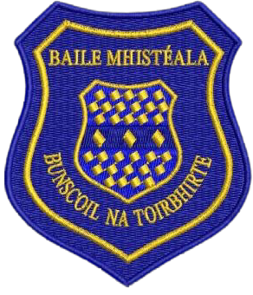
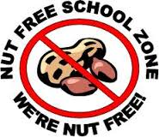
Bunscoil na Toirbhirte is a nut free zone
Healthy Lunch Policy

Bunscoil na Toirbhirte is dedicated to supporting the health and well-being of the school community, therefore the focus of this policy is to support parents, pupils and staff in relation to the promotion of healthy eating habits from an early age. Eating habits throughout life are established at a young age. Therefore, learning to choose and enjoy different foods in childhood provides the foundation for healthy food choices in adulthood. Research also indicates a strong link between diet and performance. A healthy diet promotes concentration, protects teeth and reduces health risks. As part of the Social, Personal and Health Education (S.P.H.E.) Programme we encourage the children to become aware of the need for healthy food in their lunchboxes.

This policy was formulated by consultation with staff, parents, pupils, Health Promoting School Team and the Board of Management of our school and from information gathered in healthy eating surveys.

Aim:
To ensure that all aspects of food and drink in school promote the health and wellbeing of the whole school community and that the children receive high quality education on healthy eating from a very young age.

Objectives:
- To enable the child to appreciate the importance of good nutrition for growing and developing and staying healthy.
- To encourage the child to accept some personal responsibility for making wise food choices and adopting a healthy balanced diet.

A healthy lunchbox includes:
 | One portion is:
2 portions from the  bread/cereals group | - 3 dessertspoons of cooked rice or pasta  - 2 crackers  - 1 slice of bread (preferably wholemeal or wholegrain)  - 1 round pitta bread  - ½ baguette roll*  - 1 tortilla wrap*  - 1 bagel*  * Different types of breads can be used for variety, but be aware that these versions contain more calories.
2-3 portions of  fruit and vegetables | - 1 kid-size medium fruit – apple, orange, pear or banana  - 2 small fruits – plums, kiwis, mandarin oranges  - A small bunch of grapes (8-10 grapes)  - 3 dessertspoons of vegetables (e.g. carrots)  - 1 bowl of salad – lettuce, tomato, cucumber  - Grapes & cherry tomatoes should be quartered for younger children (choking hazard)
1 portion from the  meat/meat alternative group | The child’s palm of the hand – width and depth without fingers and thumbs  - 2 slices of cooked meat, chicken or turkey breast  - 1-2 eggs (hard-boiled, sliced or mashed)  - Half a small can of tuna, salmon, mackerel or sardines  - 1-2 tbsp. of chickpea spread, for example hummus
1 portion of dairy | - 1 glass of milk (200ml) (low fat milk or semi-skimmed milk is suitable from 2 years of age as long as your child is thriving and eating a good, varied diet)  - 1 carton yogurt (125g)  - 1 matchbox size piece of hard cheese such as cheddar
A healthy drink | Water or milk are the best drinks to give.

The Food Pyramid as provided by the HSE
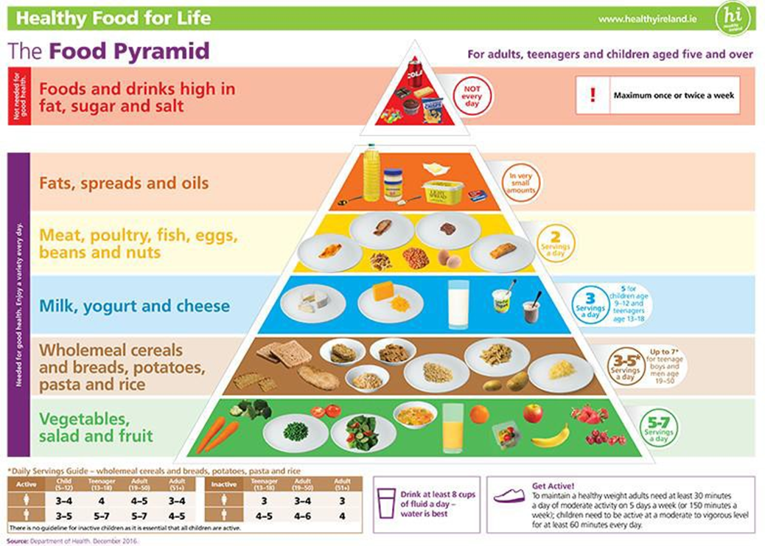

Foods and drinks that are not allowed:
The following foods and drinks do not support a healthy lunch policy and are not allowed in your child’s lunch box:
• Crisps
• Bars (including cereal bars- high sugar content)
• Sweets/ Lollipops
• Fizzy drinks and sports drinks
• Chewing gum and cough sweets (choking hazards)
• Hot drinks (health and safety concern)
• Hot food from a deli counter (these foods are very high in fat and are only safe to consume shortly after being purchased)
• Any chocolate products
• Any nut products (due to the incidence of severe allergy to peanuts and mixed nuts amongst some pupils)
Children are also told not to share lunches (due to nut allergies and religious reasons).

Food and drinks that are not encouraged:
The following foods and drinks do not support a healthy lunch policy and are not encouraged in your child’s lunch box:
- Sugar free drinks & fruit flavoured drinks (e.g. Capri Sun, Plein Süd, Rio D’Oro Sun Shots, etc.)
- Biscuits
- Salted crackers

Drinking juice or smoothies while at school is discouraged as hydrating with juice is bad for teeth and provides a ‘sugar rush’ without the fibre of the fruit. It is best for juice to be consumed with a meal at home and for water or milk to be the primary source of hydration at school.

Time
All pupils have time in the morning before their small break to eat, and they have ten to fifteen minutes at lunch break to consume their food. The staff encourage the children to eat and drink during the designated times.

Promotion
- All members of the teaching staff promote this policy through regular verbal reminders and good example to the children.
- Healthy eating will be covered in our S.P.H.E. policy.
- It is very difficult to implement the policy successfully if all children do not adhere to the guidelines. It is also not fair on the children who comply with the Healthy Eating Policy to see who children who clearly do not.

Exceptions
On treat days parents may give one small personal treat to their own child. Teachers may give treats to their own class. Children will be given advance notice of when they are allowed to bring a treat to school. Treat days would be special occasions, such as:
- End of term
- School trips
- Other specific occasions and school events
*Please remember our school is a NUT FREE ZONE! We have a number of children that are highly allergic to nuts.

Birthdays
No cakes, buns or treats are to be sent into school to celebrate children’s birthdays or other occasions. Children may only eat what their own parents/guardians give them. A child may bring a personal treat to school on his or her own birthday.

Healthy snack options.
Sometimes it can be difficult to think of healthy snack alternatives. Here are some tasty ideas.
- Fruit (for example, an apple or banana, handful of grapes)
- Washed, raw vegetable pieces (for example, sticks of carrot, celery, pepper and cucumber)
- Washed, raw vegetables (for example, cherry tomatoes)
- Plain breadsticks, unsalted plain or whole-wheat crackers, crispbreads, oat or water biscuits served with fruit or cheese.
- Plain rice cakes.
- Natural or low fat yogurt with fresh fruit
- Wholemeal or plain scones.

Green School
As a Green School, we aim to be environmentally friendly, and we therefore encourage parents to try and reduce the amount of packaging in their child’s lunchbox, e.g. tin foil, cling film, plastic bags. Reusable lunchboxes with compartments are a great way to keep lunches fresh without extra packaging. Reusable beakers are also encouraged to reduce the amount of packaging. Any wrapping or waste left after lunch is brought home in the child’s lunchbox. We would greatly appreciate your cooperation with this matter.

References:
Irish Nutrition and Dietetic Institute
Health Services Executive
Safe Food
National Dairy Council

This policy was revised by the staff in consultation with the parents. This policy ratified by the Board of Management at a meeting on the 22/09/2022. This policy will be reviewed every two years.

Signed: Patrick Mullins, Chairperson B.O.M.

Bunscoil na Toirbhirte is a nut free zone
